**Database Group Project Team 11**

In our “Budget Application Project”, we tried to understand the importance of budget management and creating the best application for our users.

**Our Mission Statement:**

Our mission is to enable people and businesses to attain financial well-being by providing them with smart budget analysis and effective management. Our dedication lies in offering an extensive and intuitive budget application database that encourages good financial practices, educates decision-making, and eventually improves our users' financial health. Through the use of cutting-edge technology and adaptable features, our goals are to make budgeting easier, encourage transparency, and instill trust in everyone's financial planning.

1. An unnormalized set of data, including

* A list of the data items being maintained
* A set of data in a grid or spreadsheet

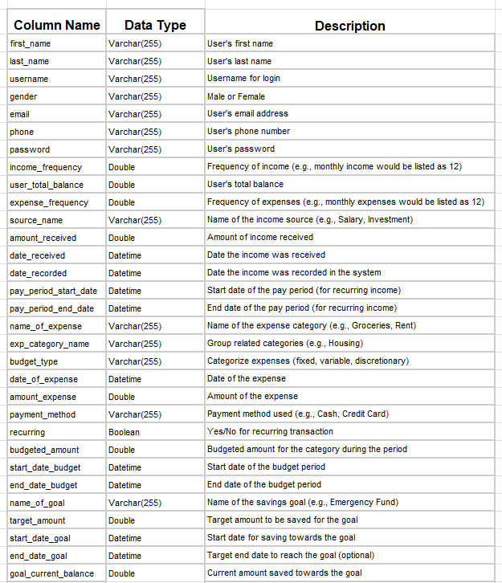

1. E-R Diagram for our 3NF database (include the participation/cardinality information… 0…* , 1..1 , etc.)

metin, diyagram, paralel, plan içeren bir resim

Açıklama otomatik olarak oluşturuldu

1. SQL queries for creating tables and inserting data from the UNF database table into the tables created.

**User**

CREATE TABLE User AS

SELECT first_name, last_name,

username, gender,email,

phone, password, income_frequency, expense_frequency , user_total_balance

FROM UNF;

ALTER TABLE User

ADD COLUMN profile_image MEDIUMBLOB,

ADD COLUMN job VARCHAR(255),

ADD COLUMN user_id BIGINT NOT NULL PRIMARY KEY AUTO_INCREMENT;

ALTER TABLE UNF

DROP COLUMN first_name,last_name, username, gender,email,

phone, password, income_frequency, expense_frequency , user_total_balance;

**GOAL**

CREATE table goal AS

SELECT name_of_goal, target_amount, start_date_goal, end_date_goal, goal_current_balance

from unf;

ALTER table goal

ADD COLUMN user_id BIGINT NOT NULL,

ADD COLUMN goal_id bigint not null PRIMARY key AUTO_INCREMENT;

ALTER TABLE goal ADD CONSTRAINT user_id FOREIGN KEY (user_id) REFERENCES user(user_id) ON UPDATE CASCADE;

ALTER TABLE UNF DROP COLUMN name_of_goal, target_amount, start_date_goal, end_date_goal, goal_current_balance;

**BUDGET**

CREATE TABLE Budget AS

SELECT budgeted_amount, start_date_budget,

end_date_budget

FROM UNF;

ALTER TABLE Budget

ADD COLUMN user_id BIGINT NOT NULL,

ADD COLUMN budget_id BIGINT NOT NULL AUTO_INCREMENT PRIMARY KEY,

ADD COLUMN expected_budget INT;

ALTER TABLE Budget

ADD CONSTRAINT PK_budget_user_id FOREIGN KEY (user_id) REFERENCES User (user_id) ON UPDATE CASCADE;

ALTER TABLE UNF DROP COLUMN budgeted_amount, start_date_budget,end_date_budget ;

**INCOME**

CREATE TABLE income AS SELECT source_name, date_received, date_recorded, pay_period_start_date, pay_period_end_date,amount_received FROM UNF;

ALTER TABLE income

ADD COLUMN income_id bigint NOT NULL AUTO_INCREMENT PRIMARY KEY,

ADD COLUMN budget_id BIGINT NOT NULL;

ALTER TABLE INCOME ADD CONSTRAINT FK_income_budget_id FOREIGN KEY (budget_id) REFERENCES Budget (budget_id) ON UPDATE CASCADE;

ALTER TABLE UNF DROP COLUMN source_name, date_received, date_recorded, pay_period_start_date, pay_period_end_date,amount_received;

**EXPENSE CATEGORY**

CREATE TABLE Expense_Category AS

SELECT budget_type, exp_category_name

FROM UNF;

ALTER TABLE Expense_Category

ADD COLUMN category_id BIGINT NOT NULL AUTO_INCREMENT PRIMARY KEY,

ADD COLUMN budget_id BIGINT NOT NULL,;

ALTER TABLE Expense_Category ADD CONSTRAINT FK_expense_category_budget_id FOREIGN KEY (budget_id) REFERENCES Budget (budget_id) ON UPDATE CASCADE;

ALTER TABLE UNF DROP COLUMN budget_type, exp_category_name;

**EXPENSE**

CREATE TABLE Expense AS

SELECT name_of_expense, date_of_expense, amount_expense,payment_method, recurring

FROM UNF;

ALTER TABLE Expense

ADD COLUMN category_id BIGINT,

ADD COLUMN budget_id BIGINT NOT NULL,

ADD COLUMN expense_id BIGINT NOT NULL AUTO_INCREMENT PRIMARY KEY;

ALTER TABLE expense

ADD CONSTRAINT FK_exps_cat_id FOREIGN KEY (category_id) REFERENCES Expense_Category (category_id) ON DELETE SET NULL;

ALTER TABLE expense

ADD CONSTRAINT FK_budget_id FOREIGN KEY (budget_id) REFERENCES Budget (budget_id);

ALTER TABLE UNF DROP COLUMN name_of_expense, date_of_expense, amount_expense,payment_method, recurring;

**DELETING UNF TABLE**

DROP TABLE UNF

1. A view to recreate the original dataset from our 3NF Tables (this will be used for comparison purposes to the original dataset we provide as number 1 of this deliverable)

CREATE VIEW ComparisonView AS

SELECT

u.first_name, u.last_name, u.username, u.gender, u.email, u.phone, u.password, u.income_frequency, u.expense_frequency, u.user_total_balance, g.name_of_goal, g.target_amount, g.start_date_goal, g.end_date_goal, g.goal_current_balance, b.budgeted_amount, b.start_date_budget, b.end_date_budget, i.source_name, i.date_received, i.date_recorded, i.pay_period_start_date, i.pay_period_end_date, i.amount_received, ec.exp_category_name, e.name_of_expense, e.date_of_expense, e.amount_expense, e.payment_method, e.recurring

FROM User u

LEFT JOIN Goal g ON u.user_id = g.user_id

LEFT JOIN Budget b ON u.user_id = b.user_id

LEFT JOIN Income i ON b.budget_id = i.budget_id

LEFT JOIN Expense_Category ec ON b.budget_id = ec.budget_id AND u.user_id = ec.user_id

LEFT JOIN Expense e ON ec.category_id = e.category_id AND u.user_id = e.user_id AND b.budget_id = ec.budget_id;